**Lab Exercise 1**

**IT4030 –Internet of Things (IoT) 2024**

**Lab 1: Introduction to Tinkercad**

Objectives:

* Getting familiarized with Tinkercad and its features
* Creating and testing a simple circuit using Tinkercad

Background:

Tinkercad is an open source, online service for creating basic 3D shapes and developing digital prototypes of electronic components. These prototypes include basic circuits with lights, resistors, buzzers, switches etc. This lab introduces Tinkercad and how to use it to build and simulate electronic circuits.

Procedure:

1. To get started, visit the website given in the following link.

[**https://www.tinkercad.com/**](https://www.tinkercad.com/)



**B**

**Sc in**

**Information Technology**

**Year 4**

**-**

**Semester 1**

**/2**



Click on

**“Join Now”**

on the Tinkercad homepag

e.

1

1. To start using Tinkercad, click on **“Create a personal account”.**



1. To create a new account, click on **“Sign in with Google”**.



1. The following screen appears after signing in.

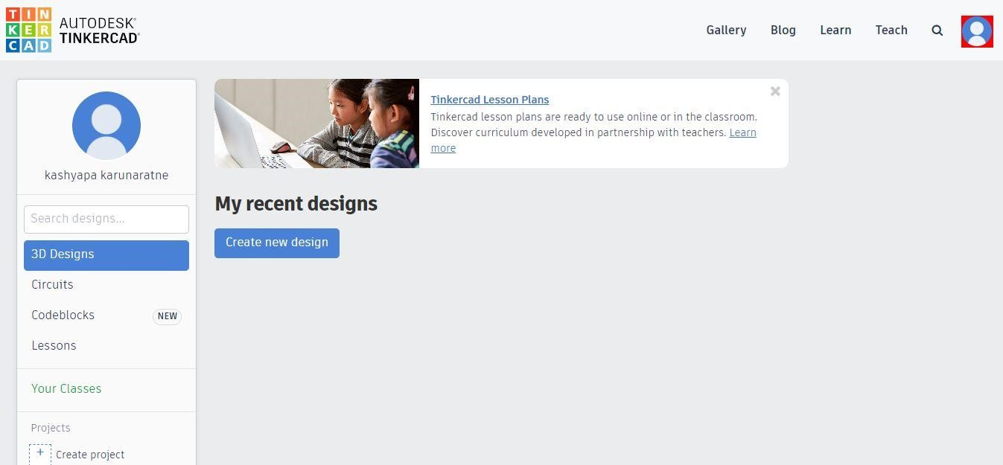

1. Click on **“Circuits”** to switch from 3D Designs to Circuits mode. This option helps to create a virtual circuit, program it, and test it in real time. Then, click on **“Create new Circuit.”**

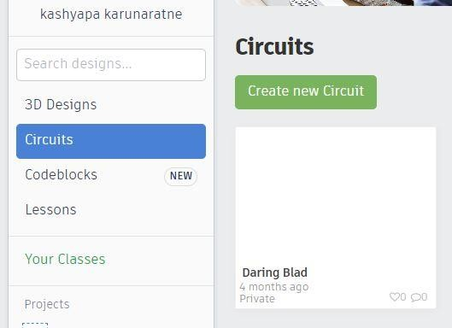

1. Then, the Tinkercad interface appears as shown below.

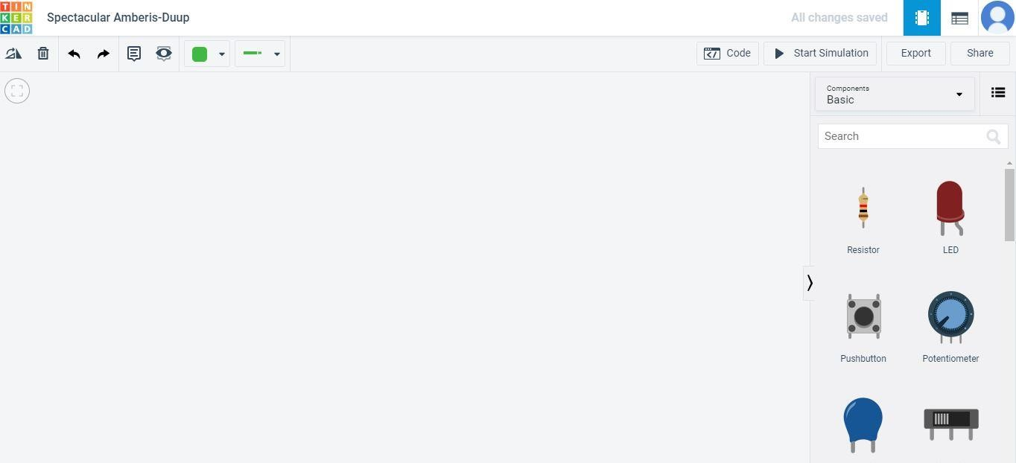

**1**

**2**

**3**

**4**

**5**

**6**

**7**

**8**

**9**

|  |  |  |
| --- | --- | --- |
| **Label No.** | **Feature** | **Description** |
| **1** | **Change name** | The name of the design can be changed from here. |
| **2** | **Main Toolbar** | From left to right: rotate the selected part clockwise, delete the selected part, undo and redo last action(s), create annotations and toggle their visibility, change wire colour and wire type. |
| **3** | **Code** | The code can be edited from here. The code can be displayed as Blocks/ Blocks+Text/Text. |
| **4** | **Start Simulation** | To start real time simulation. |
| **5** | **Export** | To export the code. |
| **6** | **Share** | To share the project. |
| **7** | **Components** | This section holds all the components. Scroll down to access component types. To get access to more components, select **All** option. |
| **8** | **Workspace** | This is the space where all the components will be placed. The components can be moved around, edited and wired together. |
| **9** | **Zoom to fit** | To fit everything into the view. |

1. Create the following circuit in Tinkercad using these components.

* + Arduino Uno R3
  + Breadboard
  + Light Emitting Diode (LED)
  + Resistor
  + Wires

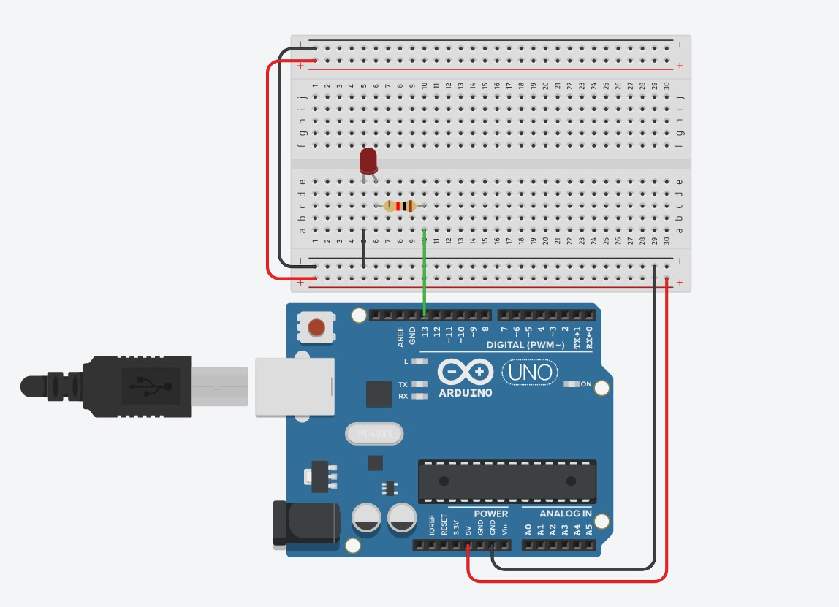

1. Enter the following C++ code.

**void setup()**

**{**

**pinMode(13, OUTPUT);**

**}**

**void loop()**

**{**

**digitalWrite(13, HIGH);**

**delay(1000); // Wait for 1000 millisecond(s) digitalWrite(13, LOW);**

**delay(1000); // Wait for 1000 millisecond(s)s**

**}**

9. Click on **“Start Simulation”** and observe the blinking LED.

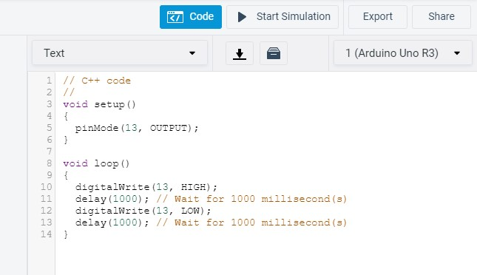

**Video**

